**Program Structure**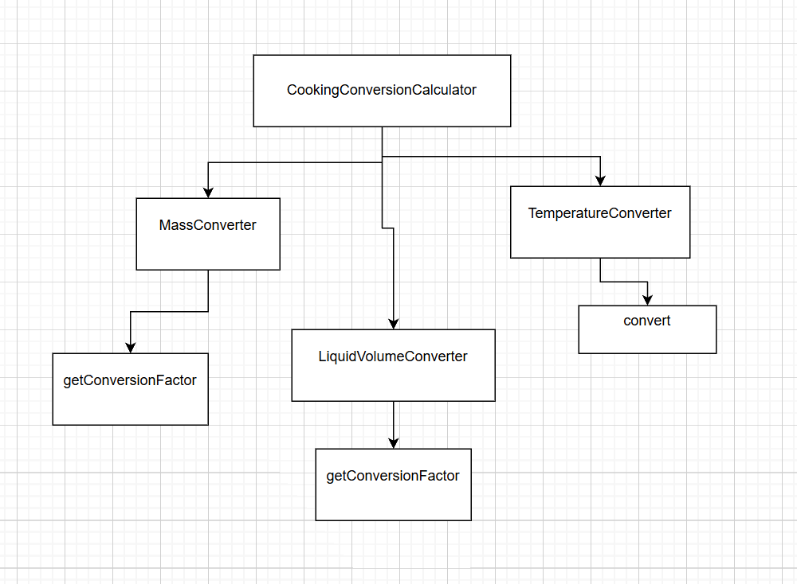

**Top-down Integration**

| Unit under test | List of Stubs/Drivers | Input | result | Stub’s return value | Expected results | Actual results | Pass/Fail/No run |
| --- | --- | --- | --- | --- | --- | --- | --- |
| TD-TEMP-1  CookingConversionCalculator.convert | Stub TemperatureConverter.convert | choice=temperature, value=10, fromUnit  =fahrenheit, toUnit=celsius | 999.99 | 999.99 | 999.99 | -0.0 | Fail |
| TD-MASS-1  CookingConversionCalculator.convert | Stub MassConverter.convert | choice=mass, value=1, fromUnit=cup, toUnit=gram | 222.22 | 222.22 | 222.22 | 125.0 | Fail |
| TD-LIQ-1  CookingConversionCalculator.convert | Stub LiquidVolumeConverter.convert | choice=liquid, value=1, fromUnit  =liter, toUnit=quart | 123.456 | 123.456 | 123.456 | 1.057 | Fail |
| TD-UNKW-1  CookingConversionCalculator.convert | - | choice=pressure, value=10, fromUnit  =pascal, toUnit=bar | - | - | 0.0 | 0.0 | Pass |

**Bottom-up Integration**

| Unit under test | List of Stubs/Drivers | Input | result | Stub’s return value | Expected results | Actual results | Pass/Fail/No run |
| --- | --- | --- | --- | --- | --- | --- | --- |
| BU-MASS-1  MassConverter.convert | Drivers :JUnit test | value=1, fromUnit=cup, toUnit=gram | - | - | 125 | 125 | Pass |
| BU-MASS-2  MassConverter.convert | Drivers :JUnit test | value=2, fromUnit  =tablespoon, toUnit=gram | - | - | 16 | 16 | Pass |
| BU-MASS-3  MassConverter.convert | Drivers :JUnit test | value=4, fromUnit=oz, toUnit=gram | - | - | 113.396 | 113.396 | Pass |
| BU-MASS-4  MassConverter.convert | Drivers :JUnit test | value=5, fromUnit  =pound, toUnit  =kilogram | - | - | 2.27 | 2.27 | Pass |
| BU-MASS-5  MassConverter.convert | Drivers :JUnit test | value=1000, fromUnit  =gram, toUnit=oz | - | - | 35.0 | 35.0 | Pass |
| BU-MASS-6  MassConverter.convert | Drivers :JUnit test | value=2, fromUnit  =kilogram, toUnit=pound | - | - | 4.41 | 4.41 | Pass |
| BU-LIQ-1  LiquidVolumeConverter.convert | Drivers :JUnit test | value=1, fromUnit=cup, toUnit=ml | - | - | 250 | 250 | Pass |
| BU-LIQ-2  LiquidVolumeConverter.convert | Drivers :JUnit test | value=1, fromUnit=cup, toUnit=oz | - | - | 8 | 8 | Pass |
| BU-LIQ-3  LiquidVolumeConverter.convert | Drivers :JUnit test | value=2, fromUnit  =tablespoon, toUnit=ml | - | - | 30 | 2 | Fail |
| BU-LIQ-4  LiquidVolumeConverter.convert | Drivers :JUnit test | value=1, fromUnit=oz, toUnit=ml | - | - | 29.574 | 29.574 | Pass |
| BU-LIQ-5  LiquidVolumeConverter.convert | Drivers :JUnit test | value=1, fromUnit=pint, toUnit=ml | - | - | 473.176 | 473.176 | Pass |
| BU-LIQ-6  LiquidVolumeConverter.convert | Drivers :JUnit test | value=1, fromUnit  =quart, toUnit=liter | - | - | 0.946 | 0.946 | Pass |
| BU-LIQ-7  LiquidVolumeConverter.convert | Drivers :JUnit test | value=100, fromUnit=ml, toUnit=oz | - | - | 3.4 | 3.4 | Pass |
| BU-LIQ-8  LiquidVolumeConverter.convert | Drivers :JUnit test | value=1, fromUnit  =liter, toUnit=pint | - | - | 2.113 | 2.113 | Pass |
| BU-LIQ-9  LiquidVolumeConverter.convert | Drivers :JUnit test | value=1, fromUnit  =liter, toUnit=quart | - | - | 1.057 | 1.057 | Pass |
| BU-LIQ-10  LiquidVolumeConverter.convert | Drivers :JUnit test | value=1, fromUnit  =liter, toUnit=gallon | - | - | 0.264 | 0.264 | Pass |
| BU-TEMP-1 TemperatureConverter.convert | Drivers :JUnit test | value=32, fromUnit  =fahrenheit, toUnit=celsius | - | - | 0 | 0 | Pass |
| BU-TEMP-2 TemperatureConverter.convert | Drivers :JUnit test | value=212, fromUnit  =fahrenheit, toUnit=celsius | - | - | 100 | 0 | Fail |
| BU-TEMP-3 TemperatureConverter.convert | Drivers :JUnit test | value=0, fromUnit  =celsius, toUnit  =fahrenheit | - | - | 32 | 0 | Fail |
| BU-TEMP-4  TemperatureConverter.convert | Drivers :JUnit test | value=100, fromUnit  =celsius, toUnit  =fahrenheit | - | - | 212 | 0 | Fail |
| BU-TEMP-5 TemperatureConverter.convert | Drivers :JUnit test | value=-40, fromUnit  =fahrenheit, toUnit  =celsius | - | - | -40 | 0 | Fail |
| BU-CALC-1 CookingConversionCalculator.convert | Drivers :JUnit test | choice=mass, value=2, fromUnit  =kilogram, toUnit=pound | - | - | 4.41 | 4.41 | Pass |
| BU-CALC-2 CookingConversionCalculator.convert | Drivers :JUnit test | choice=liquid, value=1, fromUnit  =quart, toUnit=liter | - | - | 0.946 | 0.946 | Pass |
| BU-CALC-3 CookingConversionCalculator.convert | Drivers :JUnit test | Choice  =temperature, value=32, fromUnit  =fahrenheit, toUnit=celsius | - | - | 0 | 0 | Pass |
| BU-CALC-4 CookingConversionCalculator.convert | Drivers :JUnit test | Choice  =temperature, value=212, fromUnit  =fahrenheit, toUnit=celsius | - | - | 100 | 0 | Fail |
| BU-CALC-5 CookingConversionCalculator.convert | Drivers :JUnit test | Choice  =pressure, value=10, fromUnit  =pascal, toUnit=bar | - | - | 0.0 | 0.0 | Pass |